ReClam Shellbag Report – December 2018

Introduction:
The organization overseeing this project, ReClam the Bay (RCTB), is a local, non-profit environmental organization that promotes environmental involvement and education in a constructive and helpful way. Our volunteers grow and maintain millions of baby hard shell clams (Mercenaria mercenaria) and oysters (Crassostrea virginica) in the Barnegat Bay Watershed which includes Barnegat Bay, Manahawkin Bay and Little Egg Harbor Bay. Our provides a teaching environment where people can “learn and teach by doing.” The Public can see first hand, the many services that the shellfish provide. These services include filtering the water, providing habit for other species, stabilizing shorelines and promoting economic benefits.

This Project –
RCTB has been assisting the Mordecai Island Land Trust (MILT) in the development of methods to control erosion and to restore the diverse habitat on Mordecai Island in Beach Haven, New Jersey. The island is located adjacent to the Intercoastal Waterway (ICW) and has been subjected to erosional factors as result of wave action and increased boat traffic over the years. The Army Corps of Engineers (USACOE) utilized the island in 2015 in a Beneficial Use Project to reconnect the eroded north and south islands. In 2017 the USACOE placed additional material from the ICW on the site to control the erosion (Figure 1).
In this project, shellbags containing shells from various bivalve species mostly surf clam (Spisula solidissima) were filled by RCTB volunteers and others at the Beach Haven Municipal Building property. Shellbags have been demonstrated as a successful method for oyster reef restoration and potential erosion control in temperate regions by various researchers (Taylor and Bushek 2008).
In one part of the project the shells in the shellbags contained oyster spat that had been set on the shell by RCTB volunteers using a technique called remote set of eyed larvae. In this report we will call it remote set, which is contrasted to natural set. Natural set occurs when natural spat, in the water column, sets on the naked shell in shellbags. The shellbags, were transported to the locations around Mordecai Island. In one area they were used to expand the capability of GeoTubes. Those GeoTubes were put in place over 8 years prior to this activity. The purpose was to stabilize erosion of the salt marshes. The shellbags have been effective in the retention of sand and providing a living shoreline along with protection of the GeoTube (Figure 2). Additionally, a series of shellbag barriers were placed in the northern section of the island to decrease the lost of the sand that was pumped onto to the island in 2015 and 2017 (Figure 1).
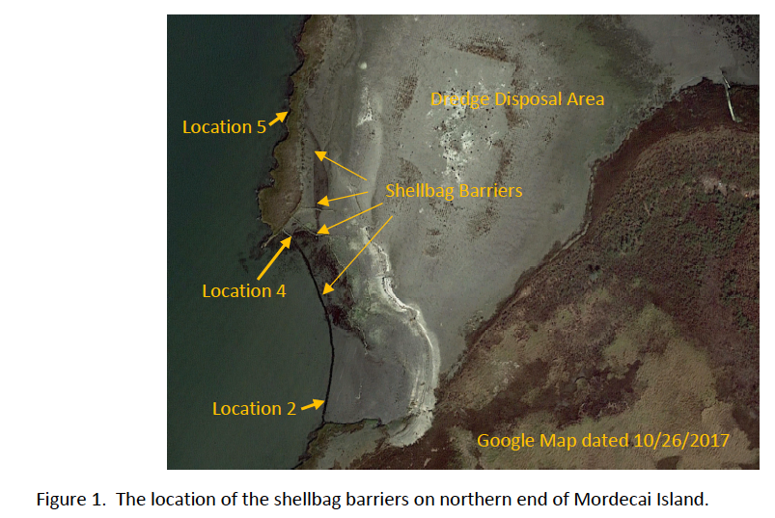 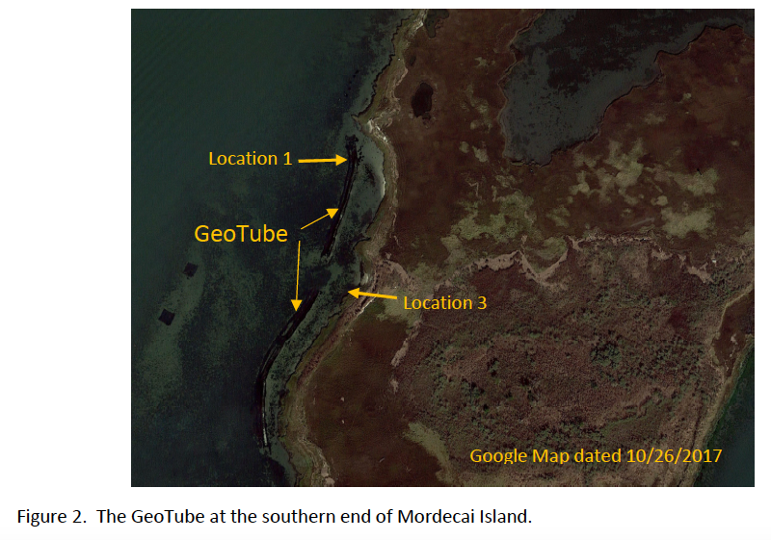The following report is an assessment of the living shoreline habitats, colonization and the utilization over the last five years. Data used in this report are taken from two years of sampling of shellbags by RCTB volunteers.

Study 1 - September 29, 2017
Objective: Assess and document the species utilizing the shellbags. Assess and document the survival of the 2015, remote set compared with other naked, shell that was not part of the remote set.
Method: Three locations were selected. Two shellbags were randomly selected from each location. Two of the locations were in front (western, open water side) of the GeoTube at the southern end of Mordecai Island. Those shellbags were placed on the bay floor in August 2015. (Photograph 2). Limy tubeworms (Hydroides dianthus) and mud snails (Ilyanassa obsoleta) were not recorded in the sampling. Location 1
- Location 1: Surf clam shell was used as the cultch material for the remote set efforts (shellbags)
- Location 2: Surf clam shell without added remote set oysters
- Location 3: The northern section of the island was occupied with hard clam shell without added remote set oysters and placed on sandy bottom (2016, cultch naked upon placement)
Shellbags were collected and placed in individual buckets and returned to the ReClam site to analysis. The analysis of the shellbags was conducted by volunteer members of ReClam. Numbers of oysters were reported along with any additional organisms.
Results:
Shellbag data from the September 29, 2017 survey

 | Location 1 |  | Location 2 |  | Location 3
 | 1 | 2 | 3 | 4 | 5 | 6
Number of shells surveyed | 55 | 58 | 114 | 217 | 94 | 70
Oyster spat 1st yr live | 10 |  |  |  | 12 | 12
Oyster spat 1st yr dead | 163 | 232
Oyster from spat 2nd yr live
Oyster from spat 2nd yr dead * |  | 4 |  | 1
Blue Mussels |  |  | 1 |  | 394 | 190
Ribbed Mussels |  |  |  |  | 3 | 4
Slipper Shell | 3 | 1 | 10 |  | 24 | 45
Jingle Shell |  |  |  |  | 9 | 10
Hard shell clam |  |  |  | 1
False angle wing |  |  |  |  |  | 1
Crabs | 19 | 12 | 6 | 4 | 12 | 5
Gobie fish | 1 |  |  |  | 1 | 2
Oyster Toad fish | 1 | 2
Skilletfish |  | 1 | 1
Oyster Drill |  |  | 2

Conclusions:
- Locations for shellbags with remote set oysters must be in carefully selected so the shellbags are not covered with sediment. Almost all the remote set oysters in Location 1, died in the first year. Placing shellbags as part of a living shoreline in areas experiencing sedimentation may not be recommended.
- The shellbags provide habitat for a number of species associated with the estuarine ecosystem.
- The shellbags can provide cultch material for natural-set oysters but the bags must be placed in selected areas where they are not subjected to sedimentation.
- Shellbags act to trap sediments when placed in selected locations and could decrease erosion.
- It was difficult to sample fish populations because of their movement during sampling. It should also be noted that only species that inhabit the shells were observed.

Study 2 - September, 2018
Because of questions raised during the 2017 growing season, studies were conducted on shellbags contained mainly surf clam shells without the remote set during the 2018 season.
Objective: Assessment of the intertidal species utilizing the shellbags, including natural oyster set and the effectiveness of the shellbags in decreasing erosion.
Method: Locations were selected and shellbags were randomly selected from each location to assess organisms utilizing the shellbags. Shellbags were collected and placed in individual buckets and returned to the ReClam Beach Haven site for analysis. The analysis of the shellbags was done by RCTB volunteer. They identified a number of live oysters along with any additional organisms.
On September 7 two locations were selected and three shellbags were randomly selected from each area.
- Location 1, Figure 2: The shellbags included surf clam and hard-shell shells that were placed at the north end of the GeoTube in 2016. The shellbags were about half covered with sediment, evident by the black staining on the shells.
- Location 2, Figure 1: at the south end of the fill area, placed there in 2017 to decrease sand loss. The shellbags contained surf clam and hard shell shells.
On September 14 three location were sampled:
- Location 3, Figure 2: at the marsh edge where three surf clam shellbags placed in July 2018. The objective was to identify species colonizing the shellbags in the intertidal area in a short period of time.
- Location 4, Figure 1: was the northern end of the lower shellbag barrier adjacent to the marsh edge. The shellbags were placed there in the fall of 2017. The lower shellbags were almost completely silted in. The shellbags contained both surf and hard-shell clam shells.
- Location 5, Figure 1 was from the subtidal area were the shellbags were placed in 2015. The shellbags were almost completely silted in and difficult to retrieve, therefore only one bag could be sampled. The shellbags contained both surf and hard-shell clam shells.

Results
Location 1 Figure 1: The shellbags were placed in front of the GeoTube in 2016 for additional protection and to provide a location to assess the accumulation of sediments. Shellbags placed in this location did create a living shoreline. The bottom shellbags are completely covered with sediments and trapped several species [e.g. Eelgrass (Zostera marina, (SAV) submerged aquatic vegetation) and sea lettuce (Ulva lactuca – macro algae) (Photograph 1) The elevation of the shellbag pile was raised to the GeoTube height in 2018 by adding shellbags on top of the existing shellbags (Photograph 2). There has been accumulation of sand behind the GeoTube and it has provided a surface for oyster habitat. The problem is that the area is subjected to removal by ice (Photographs 3 & 4). A total of 13 species were identified from the shellbags but mud snails and limy tubeworms were not recorded in these samples. Natural set oysters were recorded in the sample.

Location 2, Figure 1: A shellbag barrier was constructed in 2016 with additional shellbags placed on top of the 2017 shellbags. (Photographs 5 & 6). The lower shellbag rows are completely under sand (Photograph 7). Sampling identified 16 species, but mud snails and limy tubeworms were not recorded in the sample. Natural-set oysters were recorded in the sample.

Note the difference in bay floor elevation. (Photograph 7) The volunteer in blue on the left is mid calf where the one on the right is just to the top of his shoes.

Table 1. Species recorded from the September 7, 2018 sampling.
 | September 7, 2018
Location | 1 |  |  | 2
Shellbag | 1 | 2 | 3 | 1 | 2 | 3
White claw mud crab | 8 | 22 | 8 | 16 | 21 | 10
Black claw mud crab | 63 | 31 | 10 | 56 | 15 | 17
Anemone | 1
Annelida Worm | 19 | 2 | 6 | 6 | 8 | 5
Slipper Shell | 22 | 93 | 6 |  | 5 | 7
Jingle Shell | 38 | 14 | 4 | 3 | 9 | 4
False Angelwing | 11 | 2 | 2
Barnacle | 9 | 4 |  |  | 10
Ribbed Mussel | 2 |  |  |  | 1
Razor Clam | 1
Blue Mussel | 2 | 2
Oyster** |  | 6 | 2 |  |  | 1
Sea Squirt |  | 2 |  |  | 1
Spider crab |  |  |  |  | 1
Oyster Drill |  |  |  |  | 1
Shrimp |  |  |  | 1
Square back Crab |  |  |  | 5
*Mud snails and Limy Tube worms were not recorded

Location 3: The shellbags were placed at the base of The marsh edge where wave action was cutting under the salt marsh cordgrass (Spartina alterniflora) roots and ribbed mussel (Geukensia demissa) community. (Photograph 8). The objective was to decrease the erosion and provides a living shoreline habitat, was met.

Shellbags were assessed for colonization after only two months of emersion. (Photograph 9). Natural-set oysters were identified in all three sampled shellbags along with a large number of limy tubeworms and mud snails (Table 2). Bags place in an area to reduce erosion was effective. A small beach was created and colonized by Spartina alterniflora (Photograph 10).
Location 4: The shellbags were placed at the northern end of the barrier in the intertidal habitat (Photograph 11).

Location 5: The shellbags were placed below the intertidal zone in 2016 and were always under water (Figure 1). The shellbags were difficult to collect since they were completely covered with sediment and only one shellbag was sampled. The sample did have the most ribbed mussel and blue mussels (Mytilus edulis) of any of the shellbags sampled (Table 2).

Table 2. Results from the September 14, 2018 shellbag samples.
 | September 14, 2018
Location | 3 |  |  | 4 |  |  | 5
 | 1 | 2 | 3 | 1 | 2 | 3
White claw mud crab | 20 | 5 | 8 | 11 | 7 | 5 | 6
Black claw mud crab | 4 | 20 | 21 | 13 | 10 | 9
Anemone | 1
Annelida Worm |  | 1 |  | 7 | 3 | 1
Slipper Shell | 1 | 1 | 2 | 11 | 2
Jingle Shell | 1 | 1 |  | 10 | 2 | 1
Barnacles |  |  |  |  | 7 | 8
Ribbed Mussel |  |  |  | 2 | 35 | 12 | 85
Blue Mussel |  |  |  |  | 20 |  | 30
Oyster*** | 3 | 8 | 10 | 4 |  | 8 | 9
Sea Squirt | 3 |  | 2 | 2 | 2 |  | 1
Oyster Drill
Shrimp |  |  |  | 1 |  |  | 4
Square back Crab | 1 |  | 3 |  | 2 | 15 | 27
Limy Tubeworm | 51 | 105 | 111 | 5 | 78 | 21 | 85
Gobie Fish | 1 | 1 |  |  | 1
Knobbed Welk |  | 1
Amphipod |  |  | 1 | 1 | 2 | 3 | 40
Mud Snail | 4 | 40 | 5 | 1 | 8 | 2 | 2
Parchment Worm |  |  |  | 1
Periwinkle |  |  |  |  | 1
Hard-shell Clam |  |  |  |  | 1

Results:
- After two months (Location 3), 11 animal species were observed in the shellbags in the intertidal habitat, including oyster spat. Shellbags were colonized by Spartina Alterniflora.
- Mud crabs both white and black claw and limy tubeworm are found in large numbers in all habitats.
- Natural oysters were identified in all locations.
- The older and deeper shellbag (Location 5) contained the most ribbed mussels.
Conclusions from both years:
- Shellbags are an effective method of controlling erosion while providing a living shoreline habitat for various species.
- The shellbags are colonized by various estuarine species within a very short period after their placement.
- As the shellbags accumulate sediment, they provide a habitat for vegetation including saltmarsh cordgrass in the intertidal habitat and a number submerged aquatic species in the lower tidal range.
- The longer the shellbags are in place, the more diverse communities develop.
- The shellbags can provide locations for oysters to set, but the shellbags must be placed in selected areas where they are not subjected to sedimentation. Additional sampling the 2019 will address additional questions.
- Ice scrubbing can have a severe negative effect on shellfish in living shorelines.
Species Identified during the September 30, 2018 shellbag survey Amphipod
- Atlantic mud crab, (Panopeus herbstii)
- Atlantic oyster drill (Urosalpinx cinerea)
- Atlantic slipper shell (Crepidula fornicate)
- Bay barnacle (Amphibanus improvisus)
- Blood Ark (Lunarca ovalis)
- Blue mussel (Mytilus edulis)
- Eastern oyster (Crassostrea virginica)
- False angelwing (Petricola pholadiformis)
- Gobi (Gobiosoma bosc)
- Hard-shell clam (Mercenaria mercenaria)
- Jingle shell (Anomia simplex)
- Knobbed Welk (Busycon carica)
- Limy Tubeworm (Hydroides dianthus)
- Mud Snail (Ilyanassa obsoleta)
- Oyster toadfish (Opsanus tau)
- Parchment Worm (Chaetopterus variopedatus)
- Periwinkle (Littoraria irrorata)
- Razor clam (Ensis megistus)
- Ribbed mussel (Geukensia demissa)
- Sea Squirt (Molgula manhattenasis)
- Shrimp (Palaemonetes vulgaris)
- Skilletfish (Gobiesox strumosus)
- Spider crab (Libinia emarginata)
- Squareback marsh crab (Armases cinereum)
- Striped Anemone (Diadumene lineata)
Literature Cited:
Taylor, J. and Bushek. 2008. Intertidal oyster reefs can persist and function in a temperate North American Atlantic estuary. Marine Ecology Progress Series 361: 301-306.
Any other Literature to cite?
* Comment - Sept 2017 Table
1st year, 2nd year? Is that based on size? Cease use of term spat unless they are in year one, natural or remote. Suggest measuring these next time and getting familiar with again – “spat, yearling, older”
**Comment on Table 1
Sizes would be very helpful, or at least classifications (spat, yearling, older). Did they record gapers, boxes, drill evidence, etc.?
***Comment of Table 2
Oyster - Sizes would be very helpful, or at least classifications (spat, yearling, older). Did they record gapers, boxes, drill evidence, etc.?

